1. **What Issue:**

**RAML shows an error “YAML Sequence Expected**

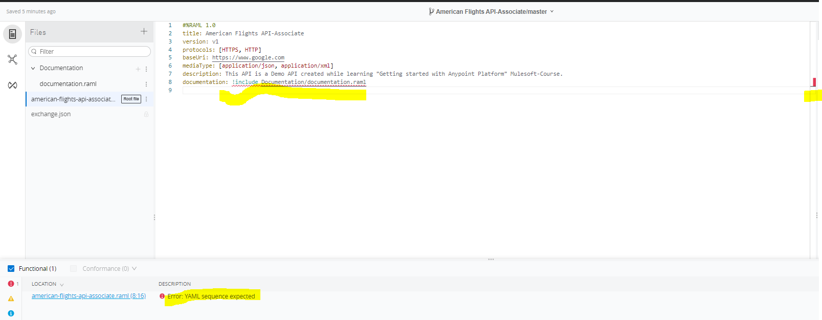

**Why Issue Occurred:**

This error we get if we are testing the RAML outside of Anypoint platform’s Design Center this is becoz we don’t have enabled mocking service as Public and not hitting the mocking service’s public url so if we test outside then we get this error.

**Solution:**  To make the mocking service as public,we have to enable the make public and copy the url that is generated n then test the Raml outside of anypoint platform

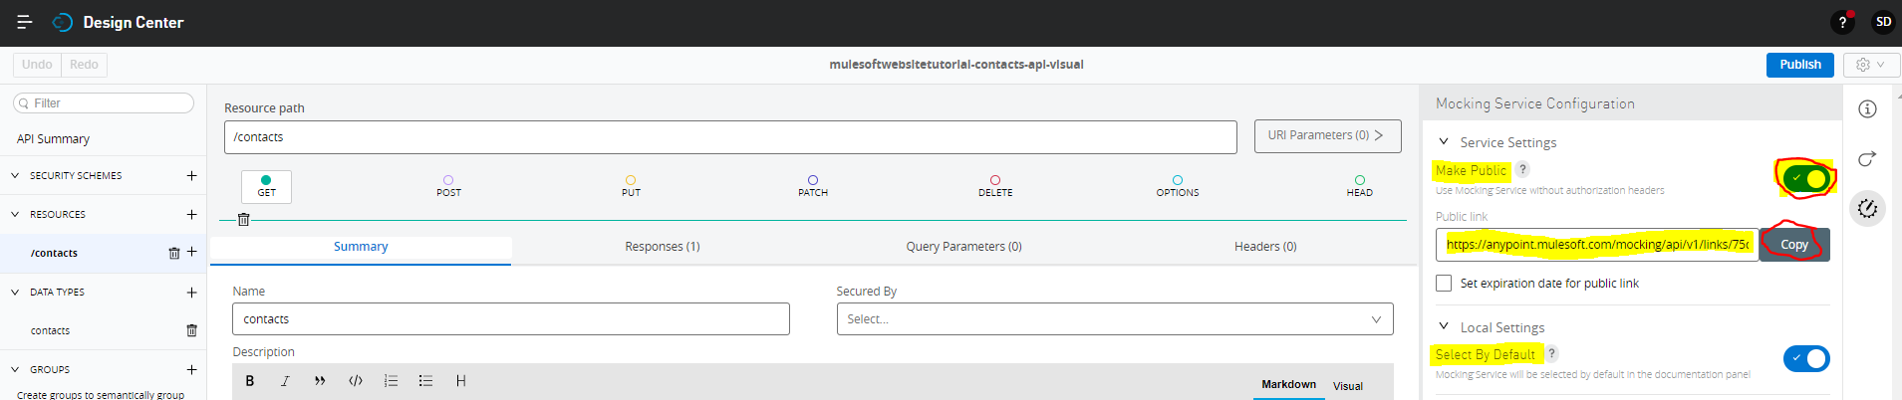

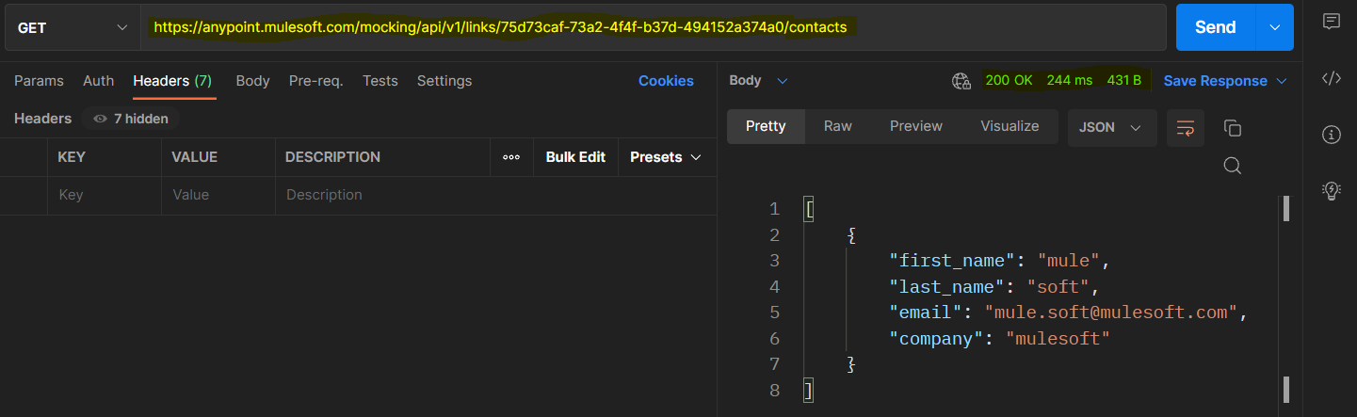

1. **What Issue:**

**RAML Testing failed with Status Code:400 and Status:Bad Request**

**No OrganizationId Header in Postman or any rest client other than Anypoint platforms Mocking service :**

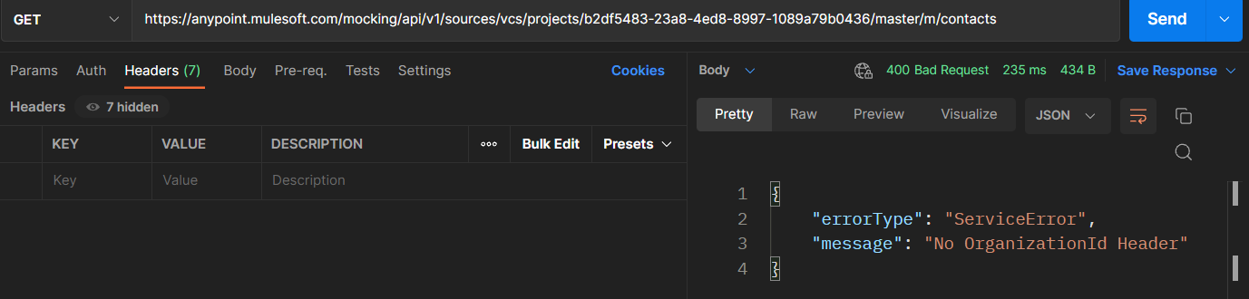

**Why Issue Occurred:**

This error we get if we are testing the RAML outside of Anypoint platform’s Design Center this is becoz we don’t have enabled mocking service as Public and not hitting the mocking service’s public url so if we test outside then we get this error.

**Solution:**  To make the mocking service as public,we have to enable the make public and copy the url that is generated n then test the Raml outside of anypoint platform





1. **What Issue:**

**Deployment Failed caused by:** org.mule.runtime.api.exception.MuleRuntimeException: org.mule.runtime.deployment.model.api.DeploymentInitException: ConfigurationPropertiesException: YAML configuration properties must have space after ':' character. Offending line is: http.port:8091

**Why Issue Occurred:**

In .yaml file we have specified a property- value right after ’:’ property-name:property-value eg: http.port:”8091”

**Solution:**

Since .yaml file properties need to have space after ‘:’ we need to specify the values in property-value after a space after ‘:’ .for eg: http.port: “8091”

1. **What Issue:**

**Deployment Failed caused by:** org.mule.runtime.api.exception.MuleRuntimeException: org.mule.runtime.deployment.model.api.DeploymentInitException: ConfigurationPropertiesException: YAML configuration properties only supports string values, make sure to wrap the value with " so you force the value to be an string. Offending property is http.port with value 8091

**Why Issue Occurred:**

In .yaml file we have specified a property- value which is not enclosed in “property-value” for eg: http.port: 8091

**Solution:**

Since .yaml file only supports string values we need to specify the values in “”.for eg: http.port: “8091”

1. **What Issue:**

**Deployment Failed caused by:** Failed to deploy artifact 'hello-mule',

org.mule.runtime.deployment.model.api.DeploymentInitException: +

+ NumberFormatException: For input string: ""8091""

**Why Issue Occurred:**

In .properties file we have specified a property-value “8091” property-name:property-value eg: http.port=”8091”

**Solution:**

Since 8091 is a number so we need to specify http.port=8091 in .properties file other values where we have combination of number n letters or just letters can be specified as http.host=”<http://0.0.0.0:8091>” or http.basepath=”/service-status”.

1. **What Issue:**

**Deployment Failed caused by:** Failed to deploy artifact 'hello-mule',

org.mule.runtime.deployment.model.api.DeploymentInitException: ResourceNotFoundException: Couldn't find resource: configurationslocal.properties neither on classpath or in file system

**Why Issue Occurred:**

In global-config.xml we have configuration-properties global element, in that we have specified configurations\${env}.properties as File field value so as we know mule has \ (backslash) as an escape character is **a character that invokes an alternative interpretation on the following characters in a character sequence**. so when we say configurations\${env}.properties after \ we have ${env}.prperties so it interpretes the configurationslocal.properties instead of configurations\local.properties and hence we get an error saying the Couldn't find resource: configurationslocal.properties neither on classpath or in file system

Note that \(backslash) as an escape character in the configurations\${env}.properties is taken into consideration becoz here we are using Expression ${env} for referencing the env value if we have configurations\dev.properties then we might not get this error also.

Or if we didn’t had placed all properties file inside configuration folder then the File field value in configuration-properties global element could be like ${env}.properties where we don’t have \(backslash) so we could have not seen this error in this case also.

**Solution:**

There are multiple ways:

1. If we are using \(backslah) then replace it with /(frontslash)

file="properties/${env}/secure.properties" <=== Now it uses slash "/"

This is usable if we are using in component configuration but in this case we are configuring the configuration-properties global element which don’t allows us to randomly enter path instead it chooses from file system so we wont able to use it when we configure the configuration-properties global element.

1. Add another \(backslash) just after the \(backslash) (not tried so don’t know whether will work or not)

file="properties\\${env}\\secure.properties" <=== Now it adds another slash "/"

3) before Mule Runtime 4.3.0, the \ (backslash) is used as a simple character (mule.properties.correct.backslash.use=false) but after 4.3.0 it is used as an escape character(mule.properties.correct.backslash.use=true) soneed to change true value to be false Specify mule.properties.correct.backslash.use=false  
  
Example for CloudHub deployment)  
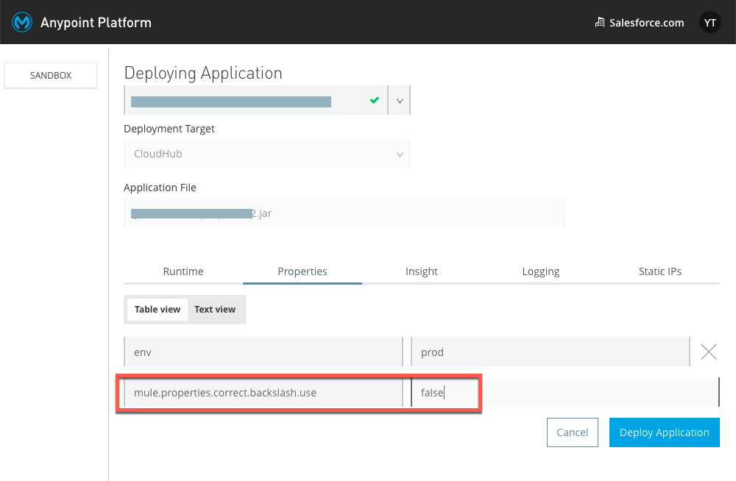  
  
Example for Studio deployment)  
